Distributor Application Form
- Custom Neon Signs

Benefits:
- Distributor’s Low Price
- Prompt Technical Supports
- Free Online Neon Sign Design Tool, Embedded to The Distributor’s Website. (This free tool may be removed if a distributor does not meet qualification.)

Company Name: ________________________________Phone: _________________
Company Website: ____________________________________________
Address: _______________________________________________
City: _______________State: __________ Zipcode:_____________________
Contact Person: _Darin Sloop__________________ Email: _________________________
Special Request: _______________________________________________________

ZLight Sales:
Email: _______________________
Phone: ______________________

Customize The Online Neon Sign Design Tool
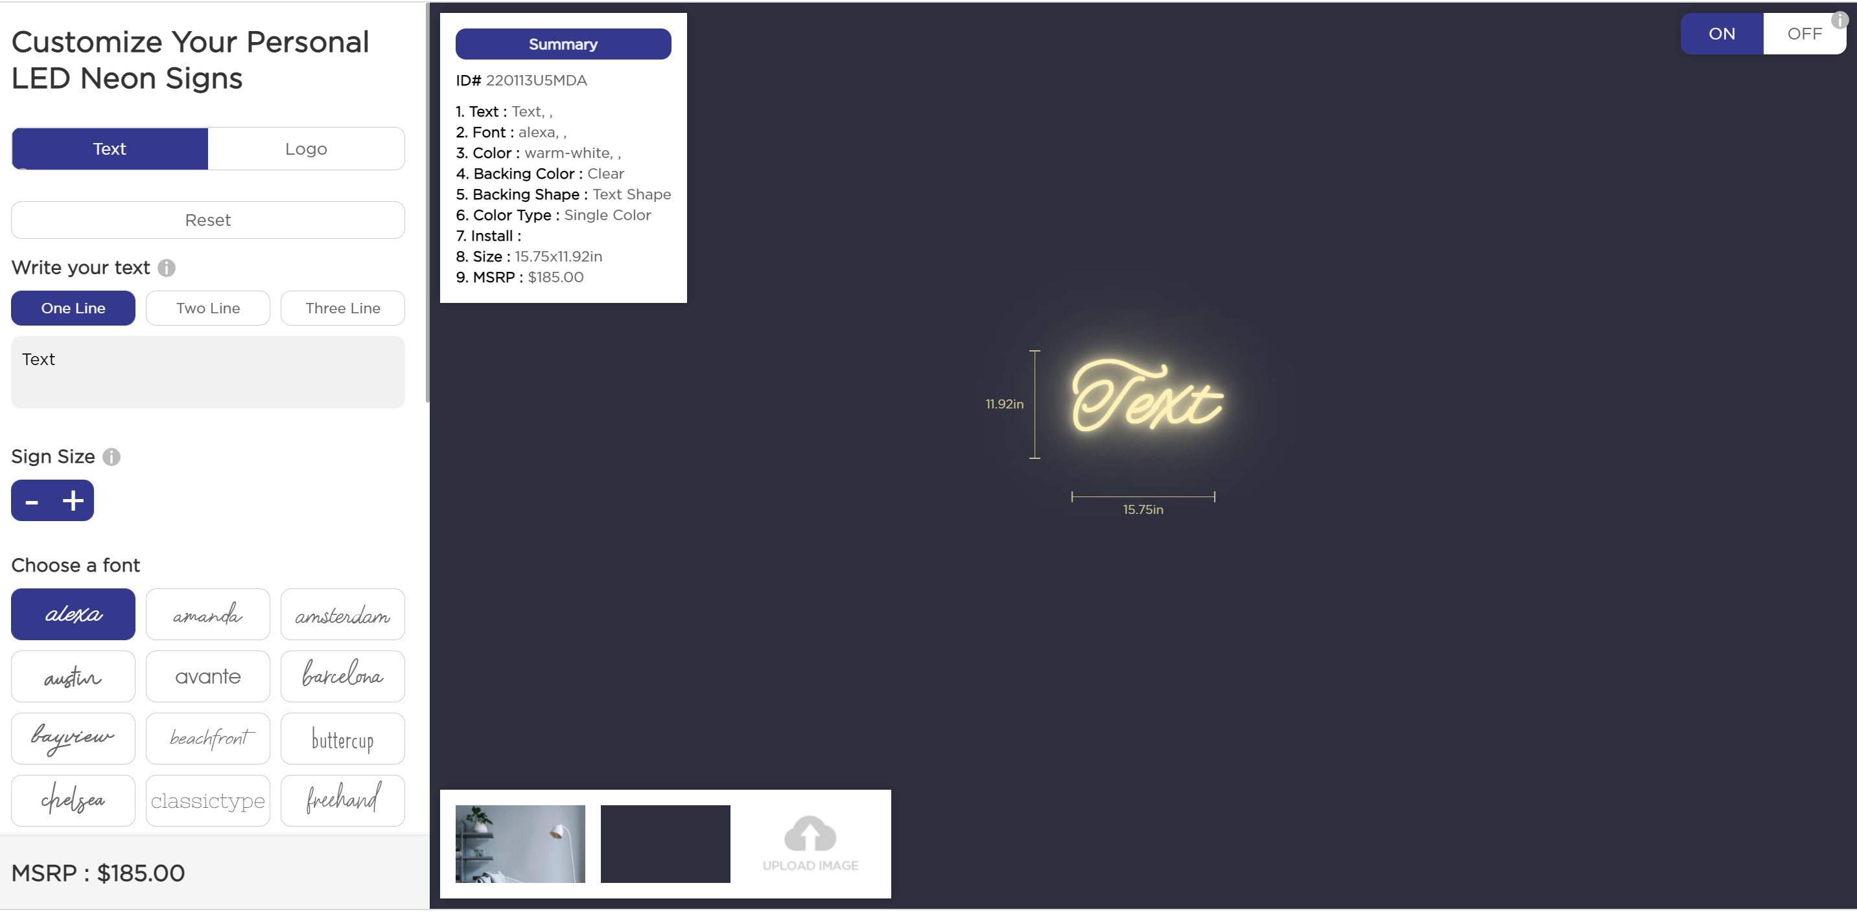
Part 3
Part 2
Part 2
Part 1

A distributor may modify the following parts to fit its own website

Part 1: Please provide your own words

Part 2: Please provide short words, no more than 7 letters

Part 3: Please provide the background pictures that you need
JPG file format, pixel 1920 x 1150

